Terraform final challenge -02
Goal of the Exercise
The goal of this exercise is to test your understanding of a Cloud Compute deployment with Terraform.
You are tasked with creating a codebase for a microservice deployment on a cloud environment, using Terraform. Since our focus is not the application itself, the service will be a simple web server that returns a static page.
Requirements
Service Details
- The service will be a simple web server that returns a static page.
- You can useapache2ornginxto serve a simple HTML file.
- The service should becontainerizedand stored in aDocker registry.
- The service should be deployed on asingle VM instanceas a docker container.
- The image should be pulled from the registry specified earlier.
- The service shouldnotbe accessible from the internet but only through aLoad Balancer, except for SSH access from specific IP addresses.
Deliverables
You are to provide the following as part of your solution:
- Dockerfileto build the image.
- Terraform codebaseto deploy the following:
  - Docker registry
  - VPC and all required networking resources
  - EC2 instance
  - Load Balancer
Notes
- Since a CI/CD pipeline is not part of this exercise, we will work around that with the help of Terraform.
- To push the image to the Docker registry,build the image locallybefore running the Terraform code.
- Once the image registry is created, use Terraform topush the local imageto the registry.
- Similarly, use Terraform topull the imagefrom the registry and run it on the VM instance once it is created.
- For SSH access:
  - Use a locally created key.
  - Add it to the cloud provider key storage.
  - Attach it to the instance.
- UseTerraform best practicesfor file structure and code organization.
  - Use variables, locals, modules, etc. when appropriate.
- Include alltfvars, scripts, and other helper files used to deploy the application.
- You may use any cloud provider of your choosing, althoughAWS is preferred.
- Use afree tier accountor atrial accountto deploy the resources.
TASK START”S FROM HERE:-
First I have created a main.tf file for root directory:
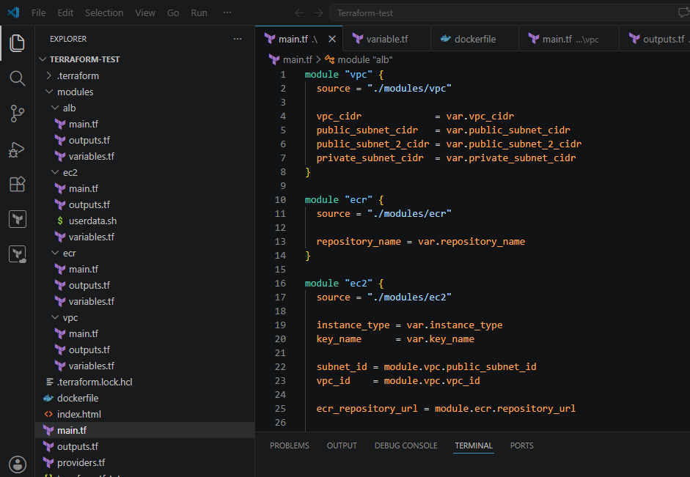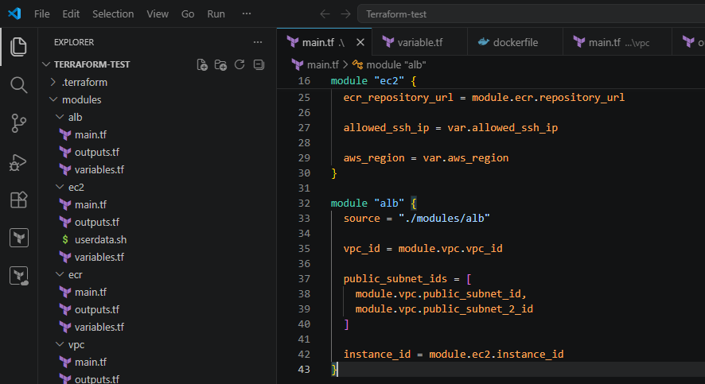Created Variables.tf file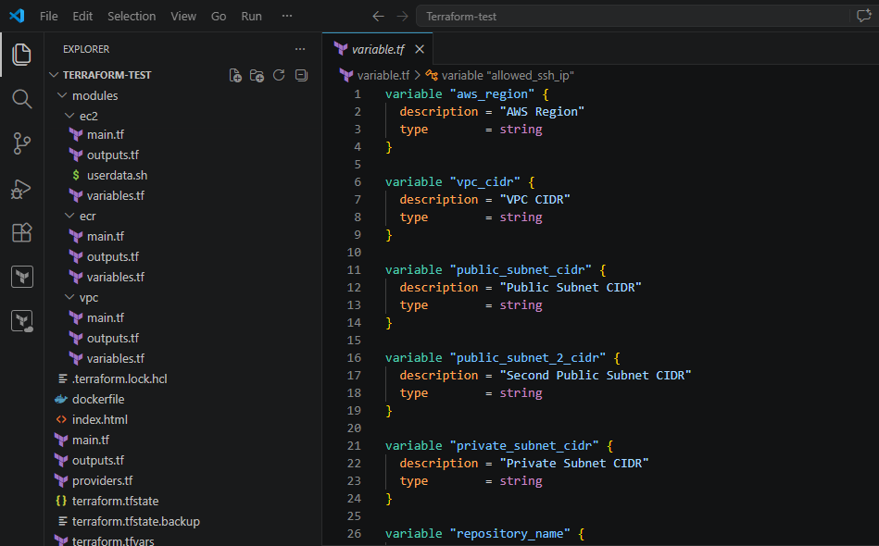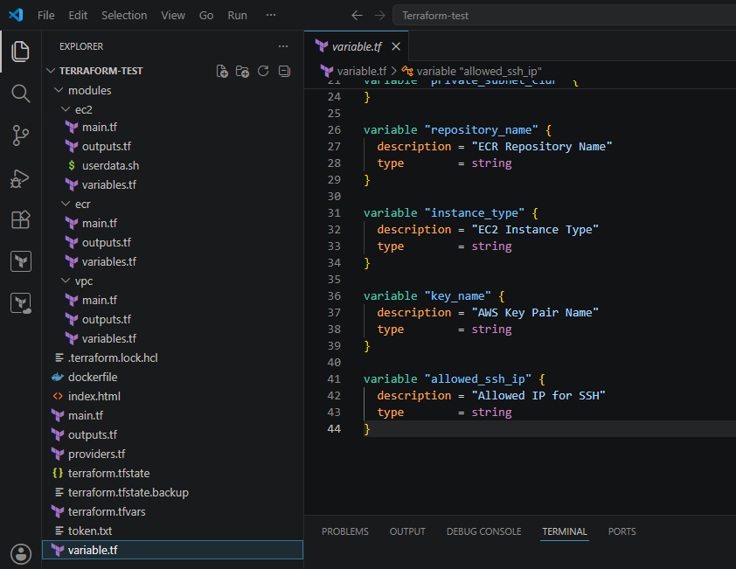Created Providers.tf file
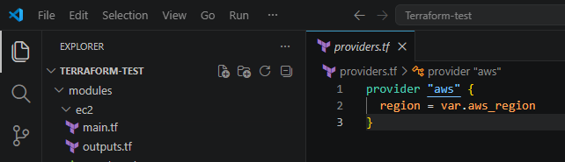
Created terraform.tfvars
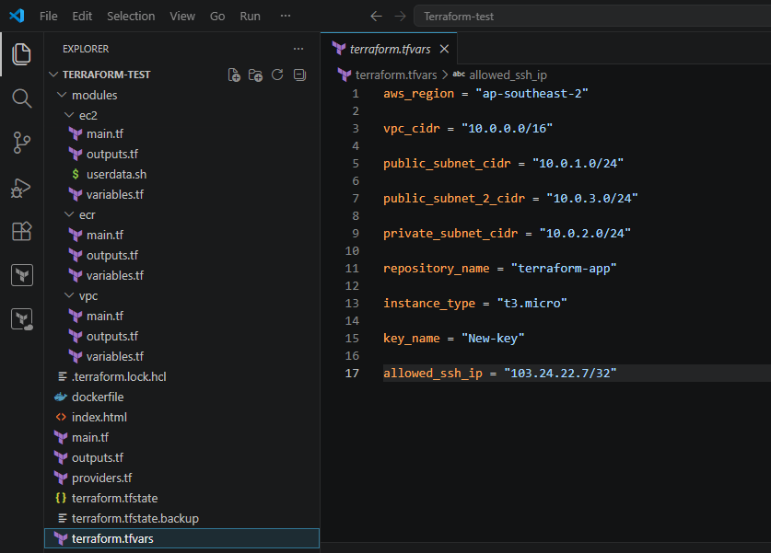Created outputs.tf file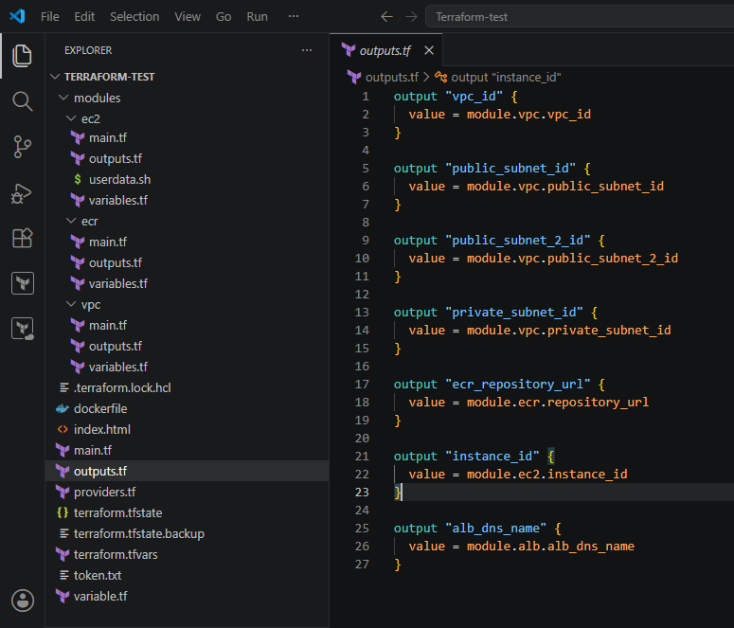Index.html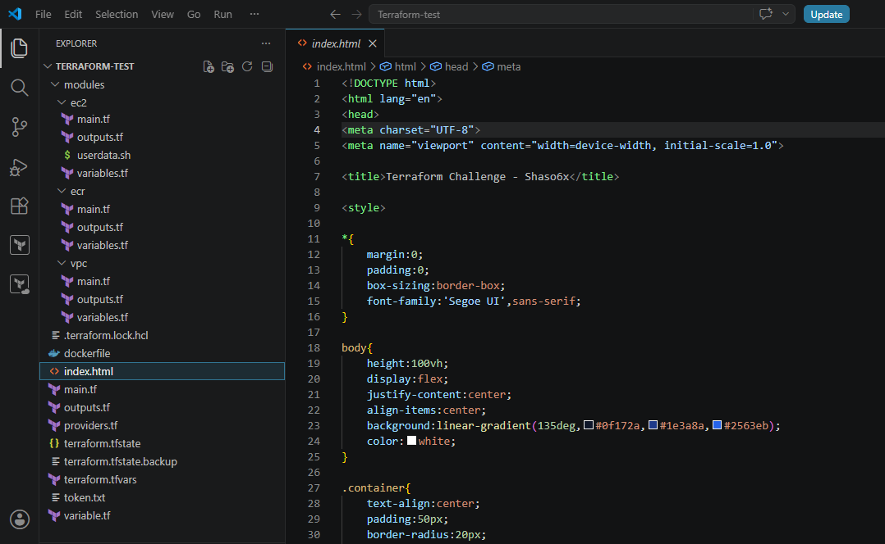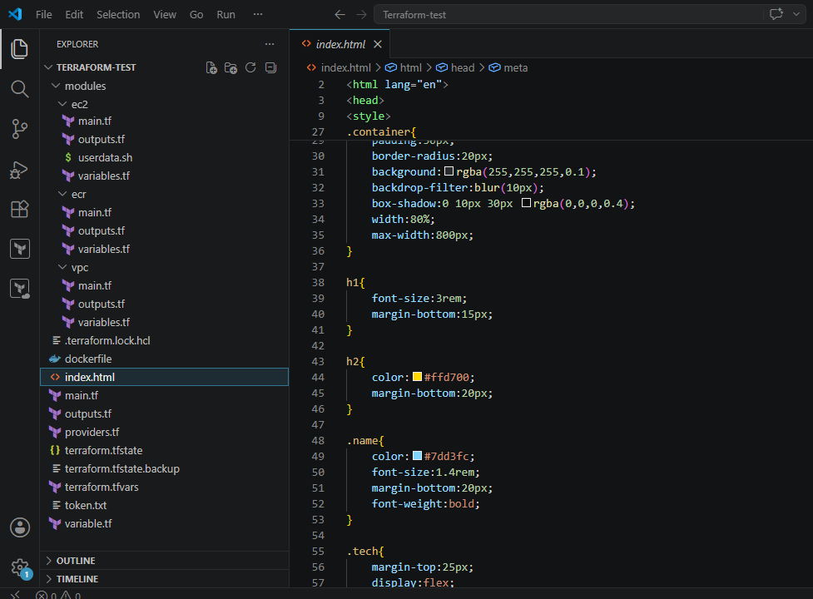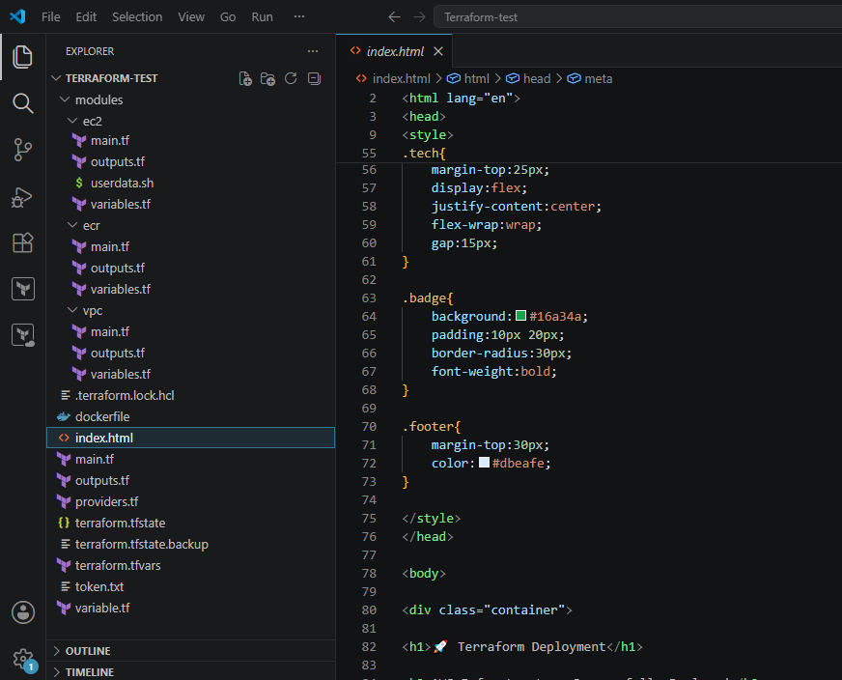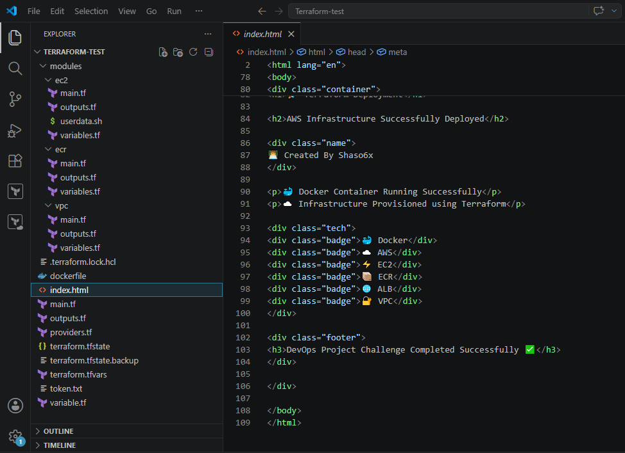Dockerfile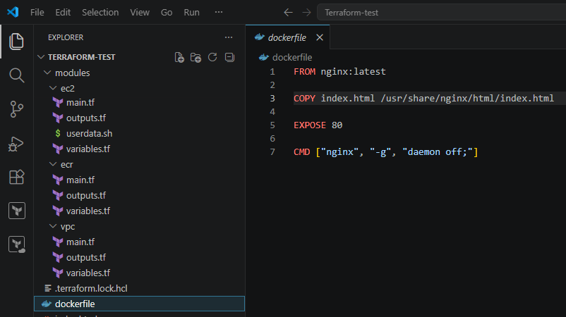
Next I have created a folder called modules and inside the folder I have
created a ec2 folder
Ec2
Main.tf
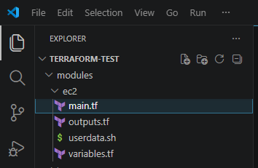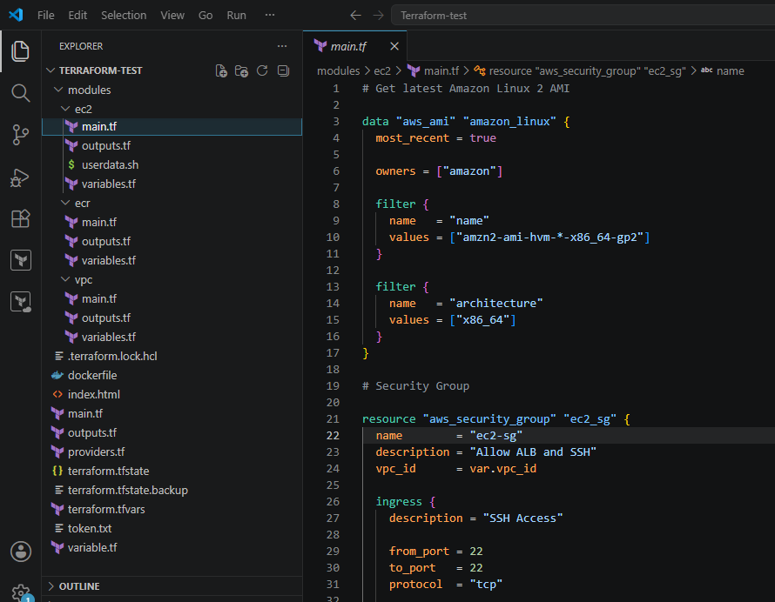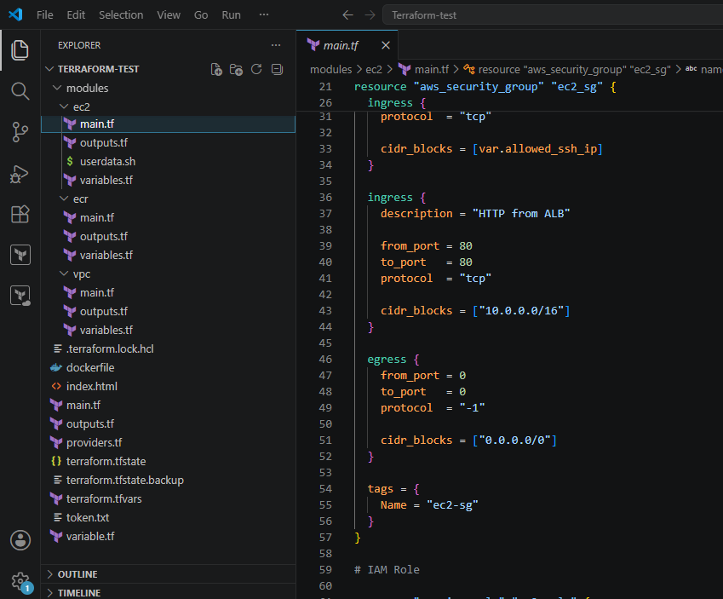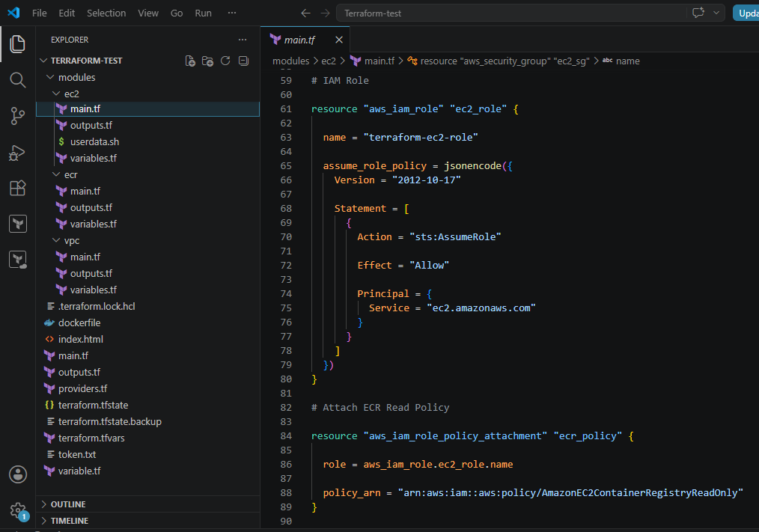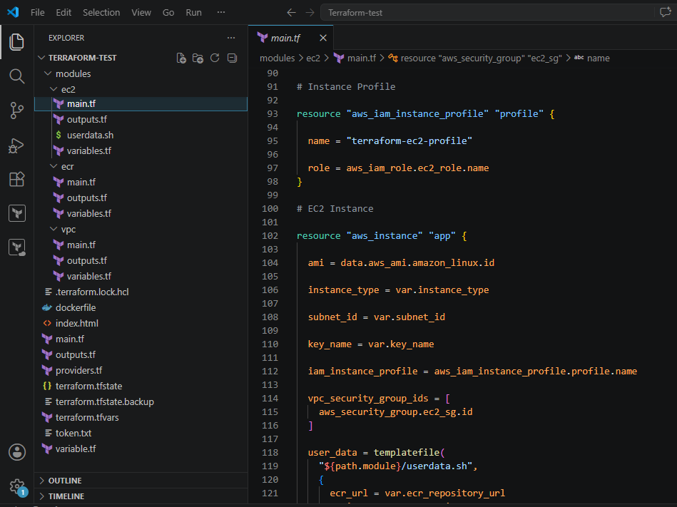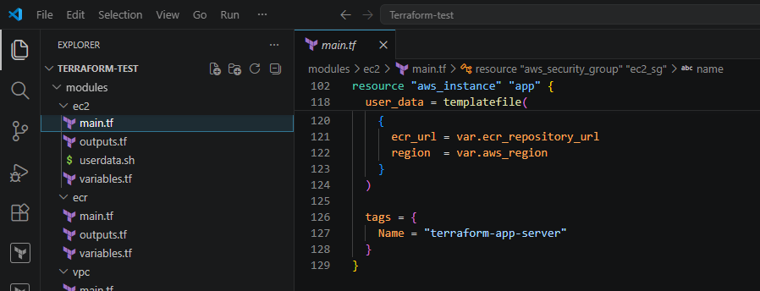Output.tf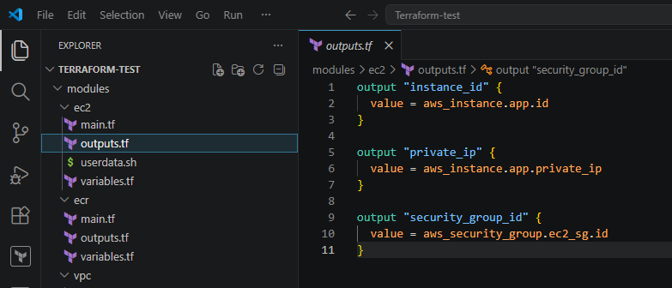Userdata.sh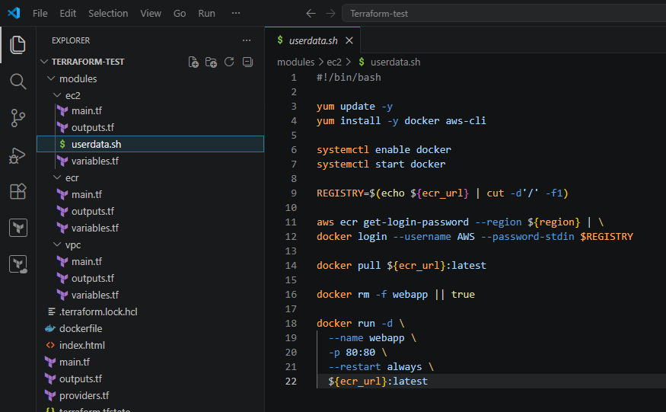Variables.tf
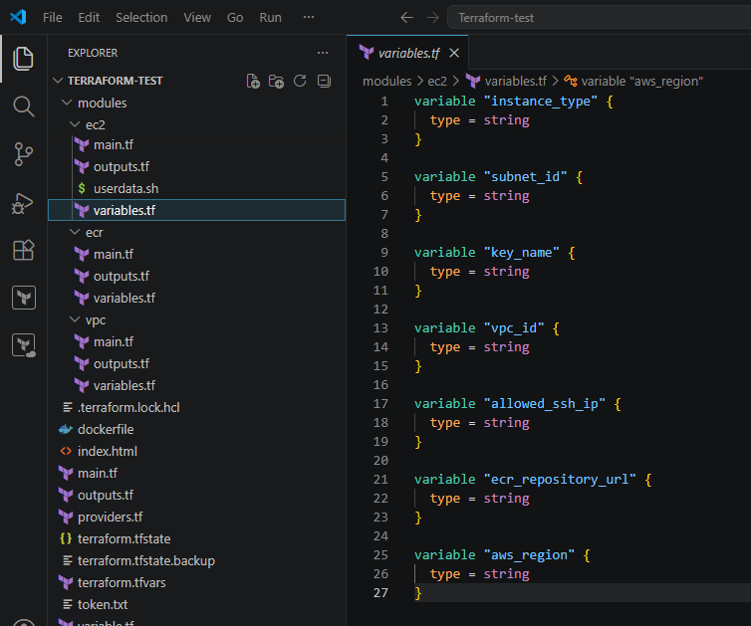Created another folder inside modules VPC
VPC
Main.tf
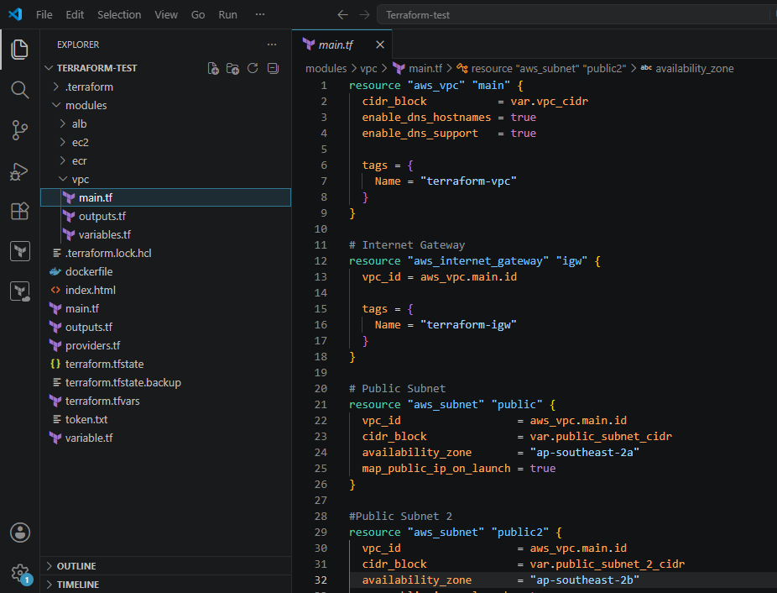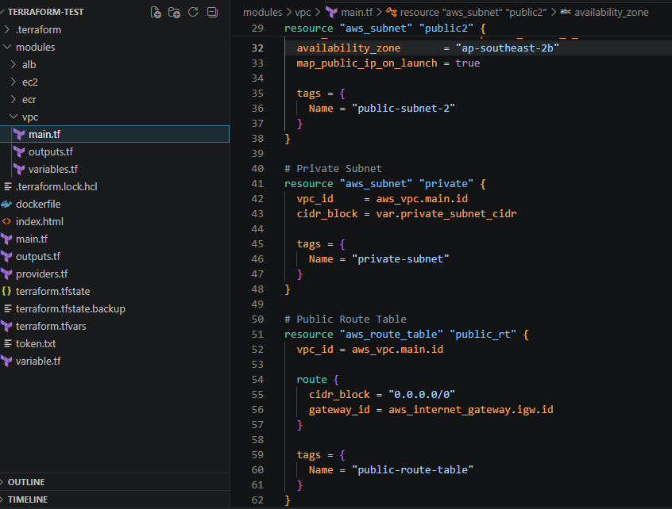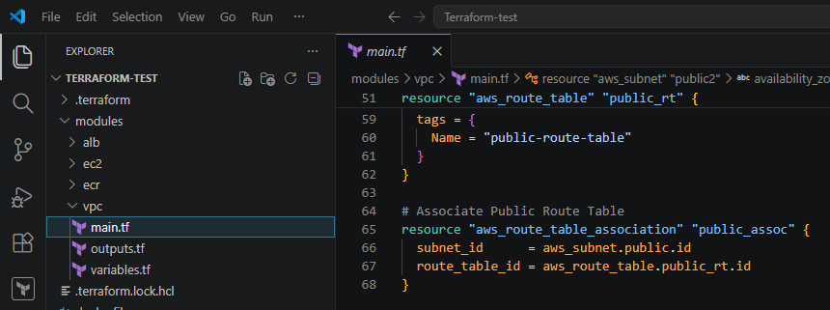Outputs.tf
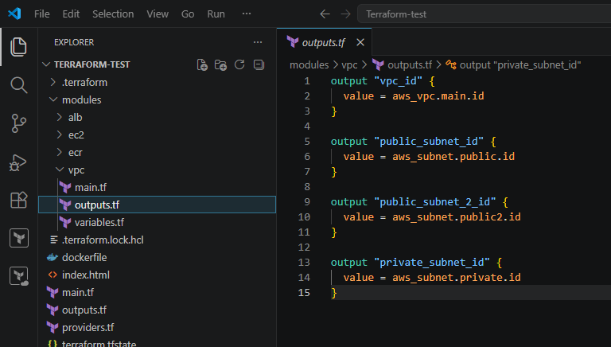Variables.tf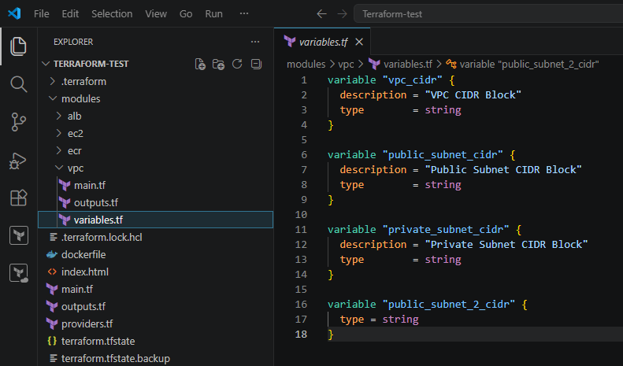Inside modules I have created another folder called ECR
ECR
Main.tf
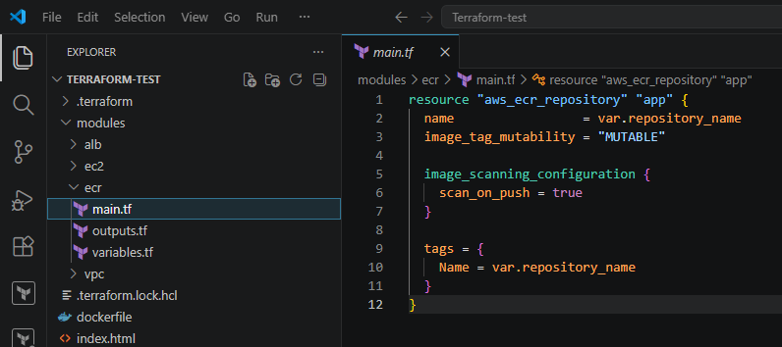
Output.tf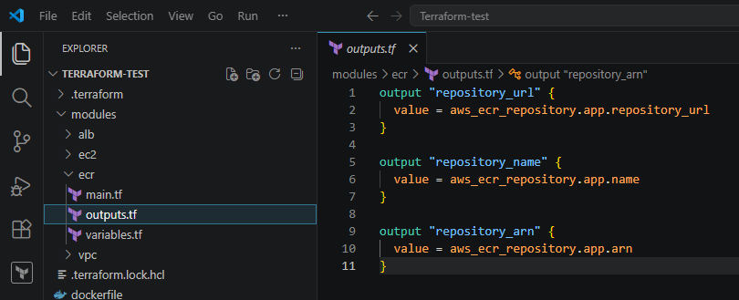
Variables.tf
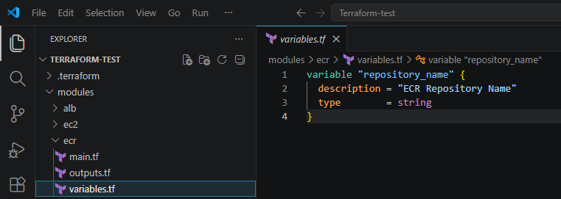
Inside modules I have created another folder called ALB
ALB
Main.tf
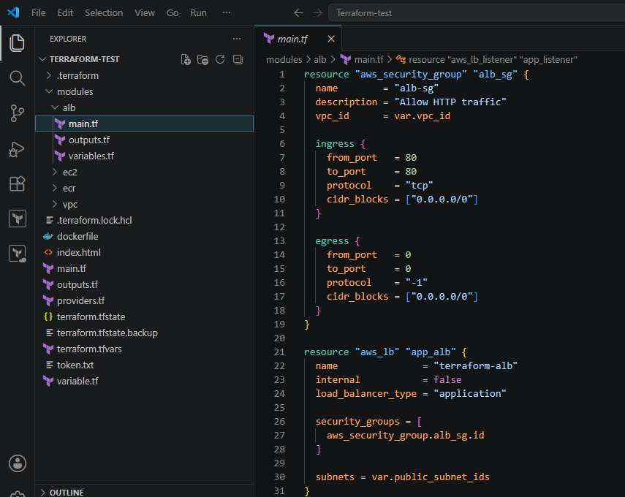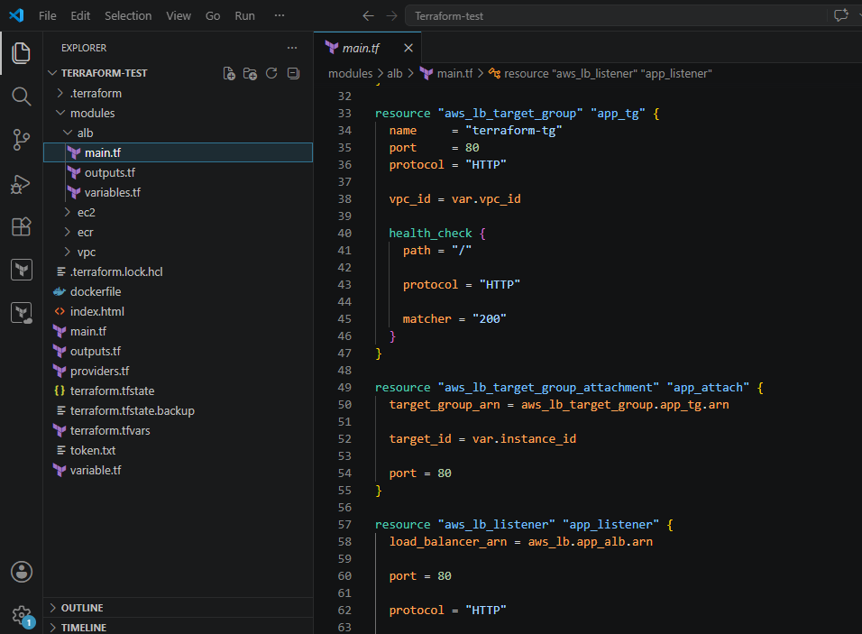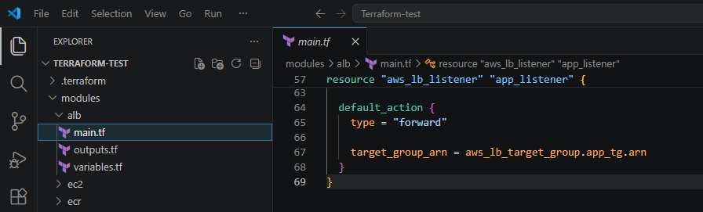Outputs.tf
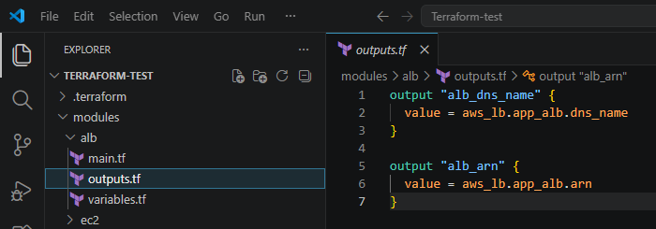
Variables.tf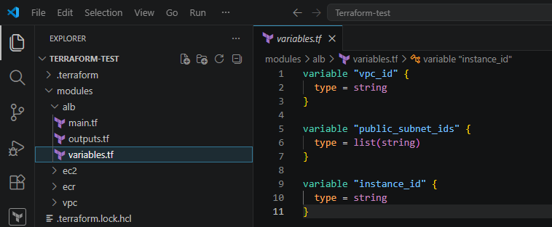
File structure
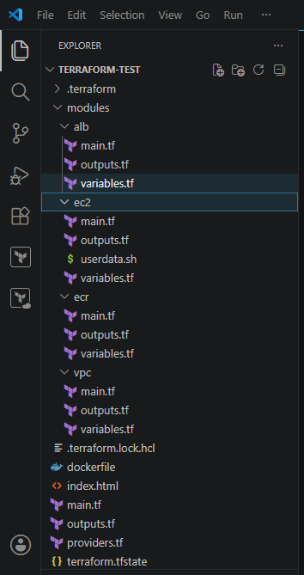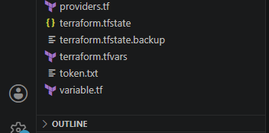
Performed
terraform init
terraform plan
terraform apply
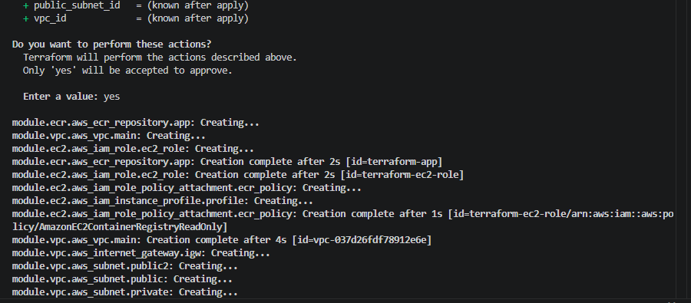 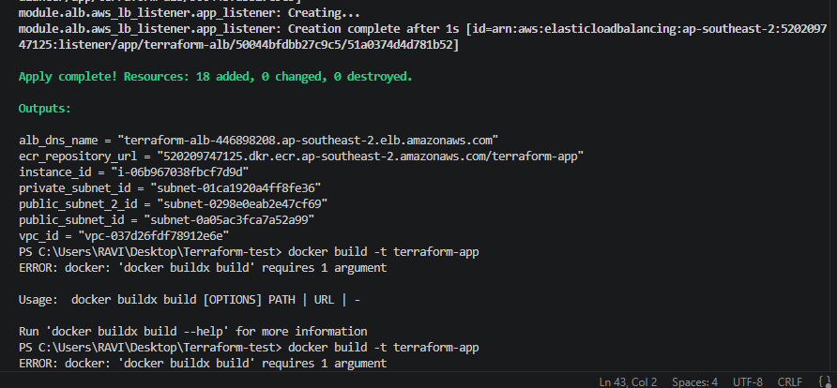
Download docker on desktop
docker build -t terraform-app .
docker tag terraform-app:latest 520209747125.dkr.ecr.ap-southeast-
2.amazonaws.com/terraform-app:latest
docker push 520209747125.dkr.ecr.ap-southeast-
2.amazonaws.com/terraform-app:latest
terraform apply -replace="module.ec2.aws_instance.app"
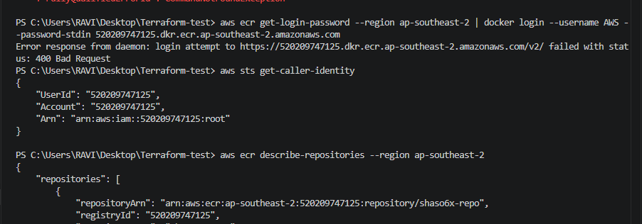 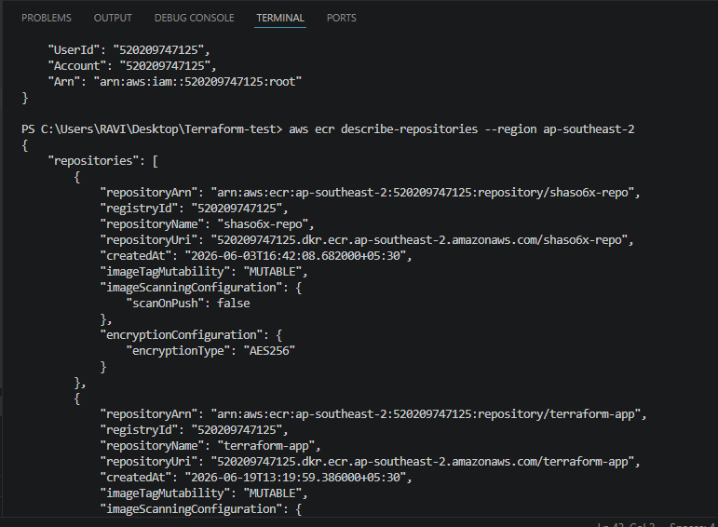
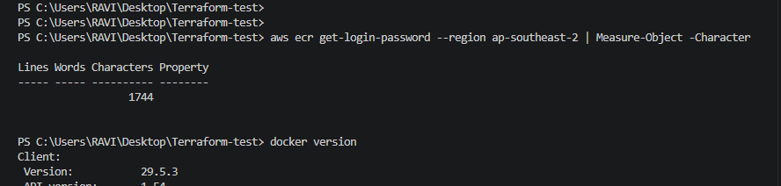
Pushed to docker
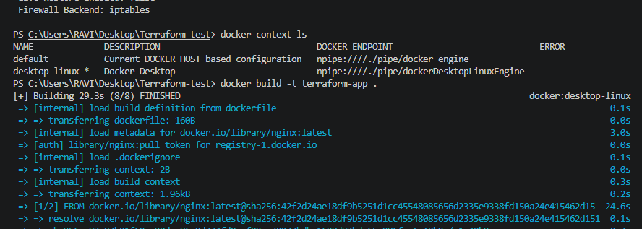
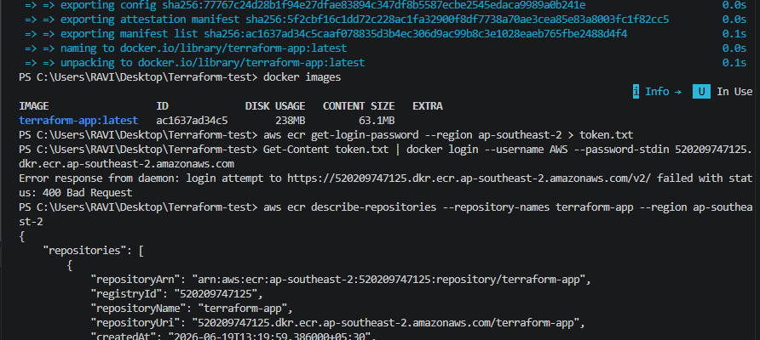 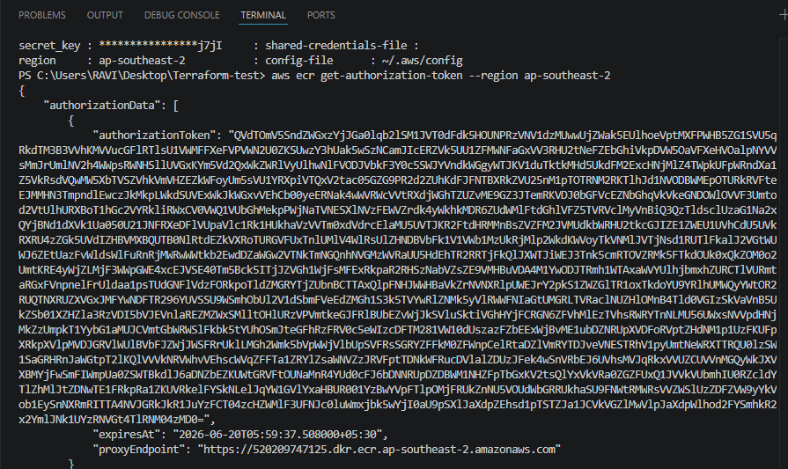 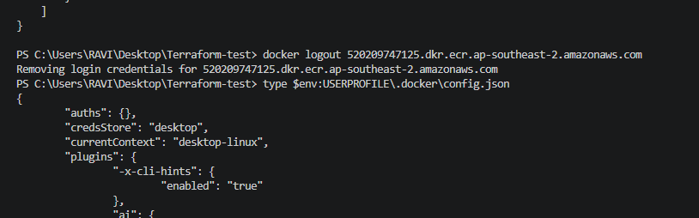 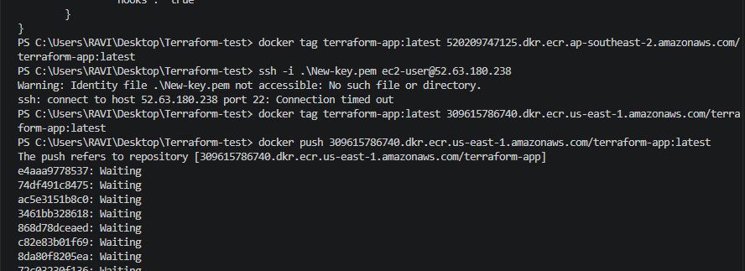 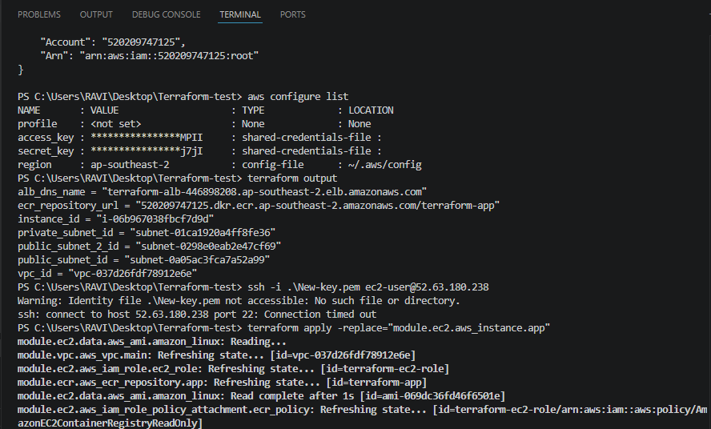 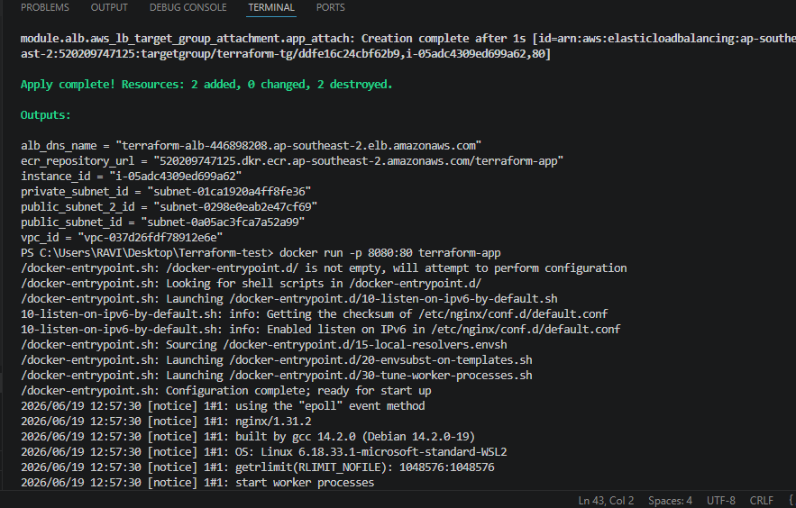
Then verified in the AWS
VPC
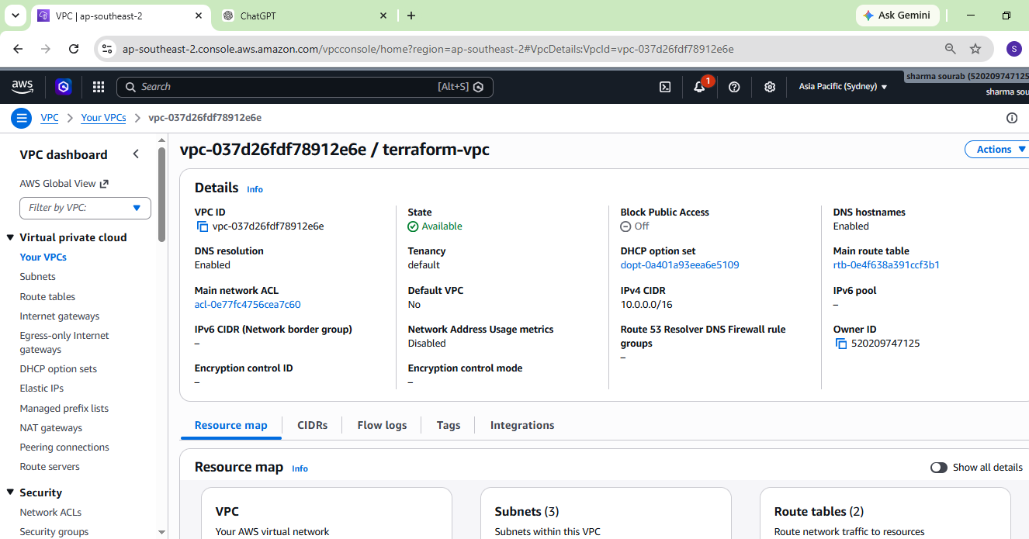
Subnets
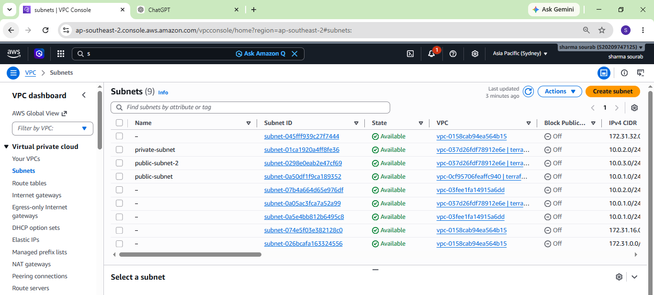
IGW is created
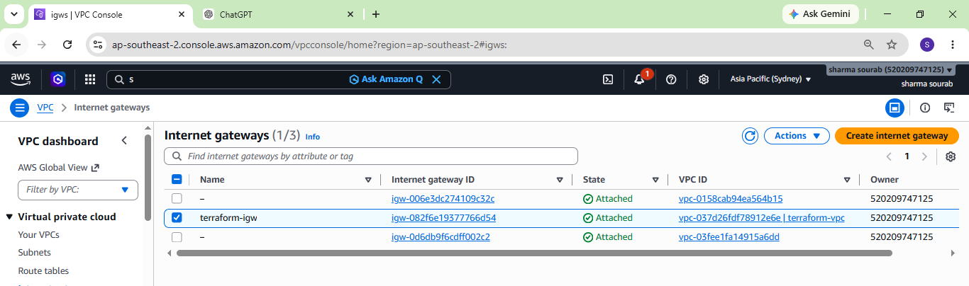
Security group is created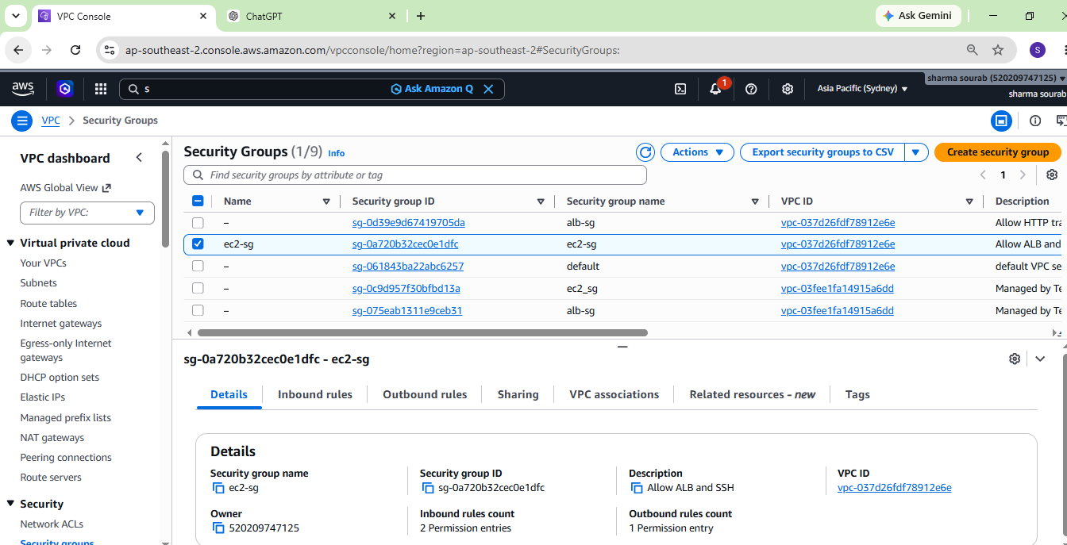
EC2 instance is created
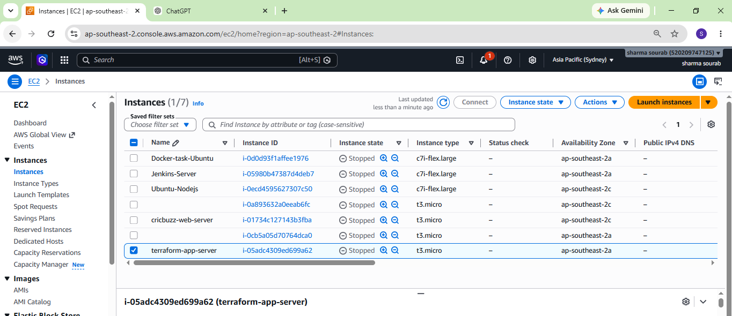
ECR is created and images are pushed
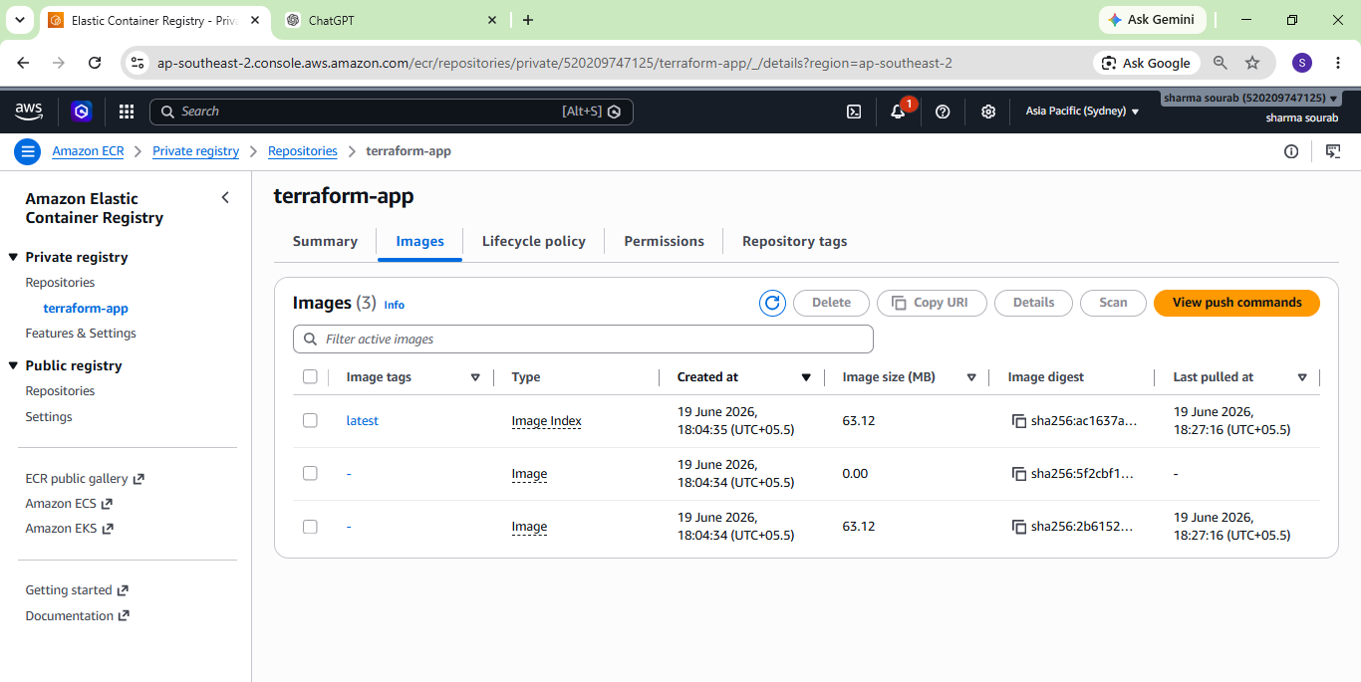
Target groups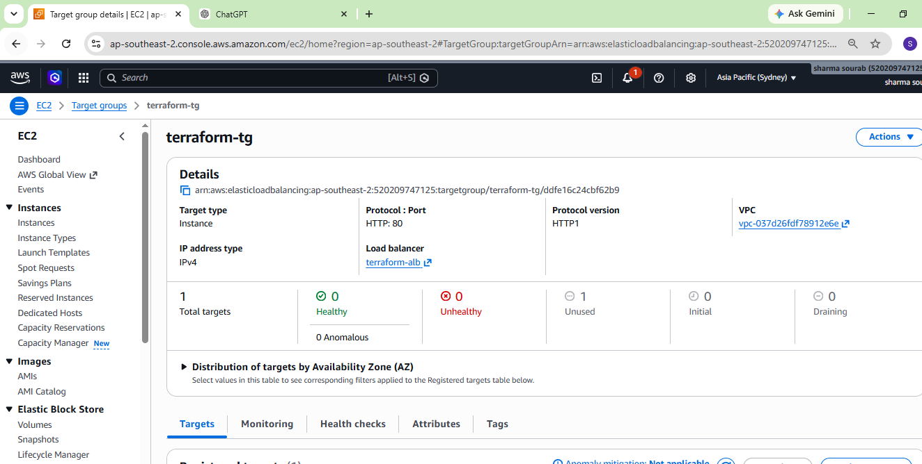
Load balancer is created successfully
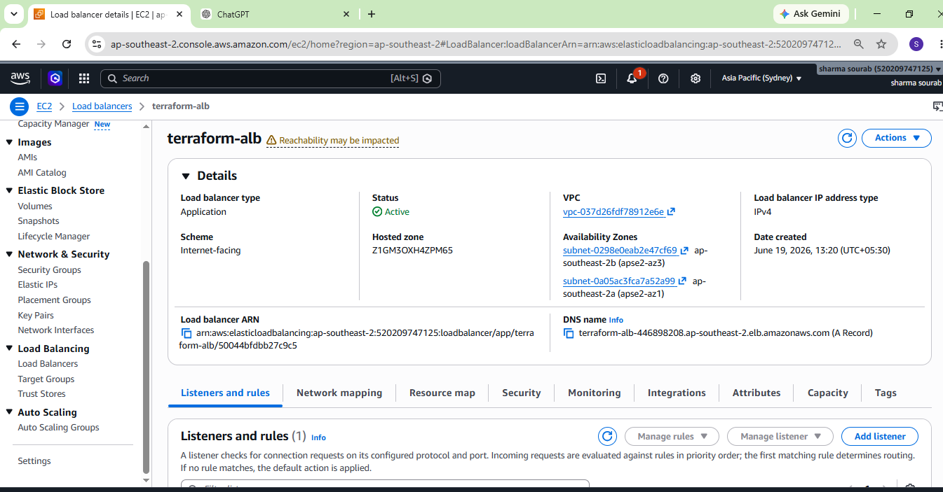
Route tables
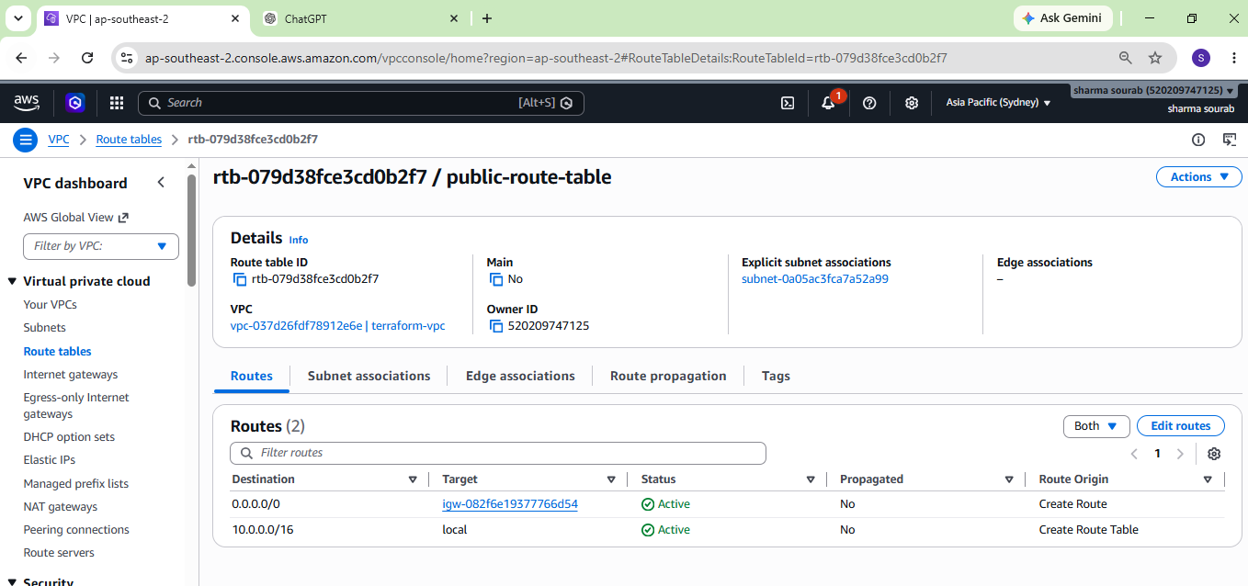
Index.html file is execute successfully with ALB DNS